CYBERNETIQUE EN NORD


Description de la carte Mechanical Main Board
Table des matières
1 Description de la carte Electronical Main Board 3
1.1.1 Présentation 3
1.1.2 Cahier des charges 3
Schéma fonctionnel 4
2 Schéma Structurel 5
3 PCB 6
4 Liste des commandes, nomenclature 7
5 Validation de la carte 8
Alimentation 8
Quartz 8
ICD2 PIC 8
RS232 port 2 + RESET 8
RS232 port 1 9
AFFICHEUR 9
GO 9
PCF8574 + I2C + SWITCH 9
6 Change Logs : 9
V1-00 : Version de base 9
V1-10 9
V1-20 10
7 Photos 11

Description de la carte Electronical Main Board

Présentation
La carte Mechanical Main Board est chargée de gérer tous les capteurs et de commander les servomoteurs.
Elle est équipée de 3 pic afin de pouvoir effectuer plusieurs taches simultanément.
Elle dispose de 15 entrées logiques 12V, de 12 commandes de servomoteurs, et de 18 entrées/sorties ou ADC.
Chaque pic peut générer un IRQ vers la carte Electronical Main Board.
Les relais on deux configurations possibles libres, ou commande de moteur, ceci à l'aide de cavailier
L'option de la commande de moteur necessite un relais simple pour la commande de marche arrêt et un relais double pour avoir les deux sens de rotation.

CONFIGURATION CONFIGURATION
RELAIS LIBRES COMMANDE MOTEUR
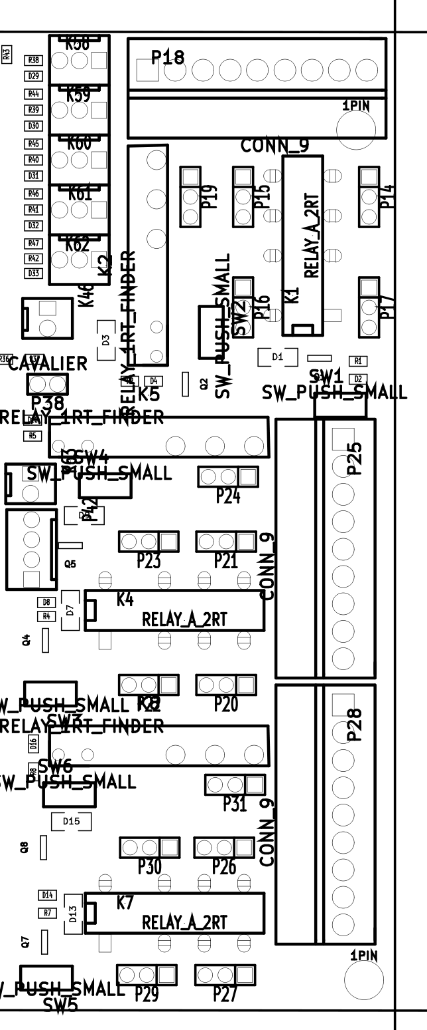

Schéma fonctionnel

Schéma Structurel

PCB
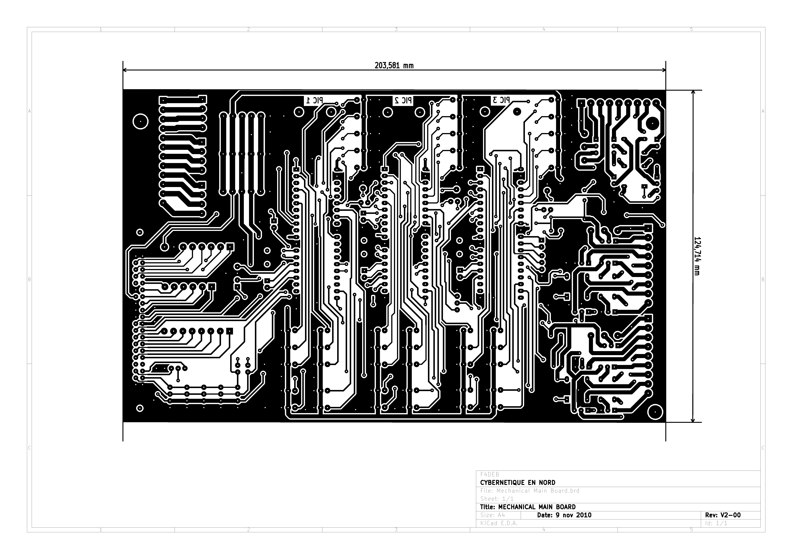

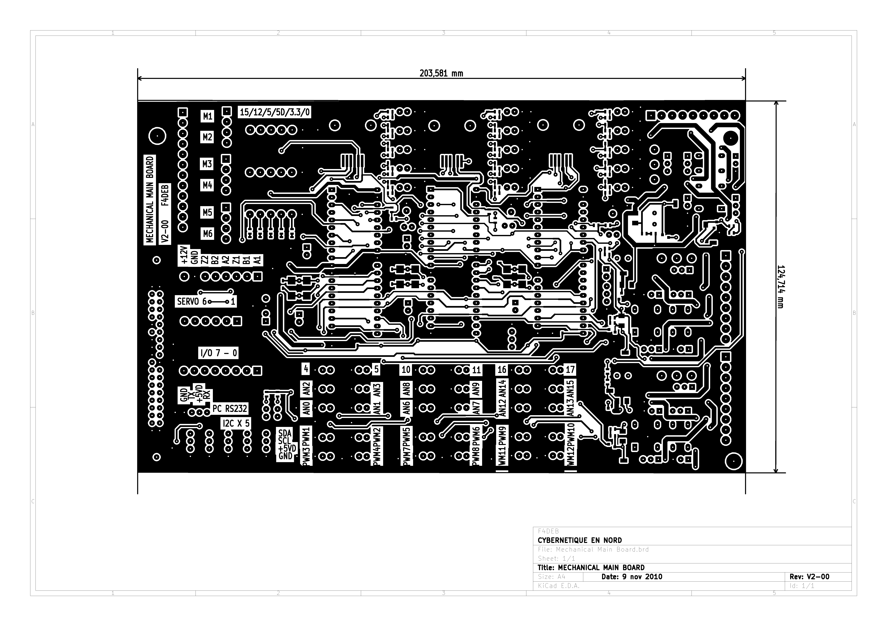
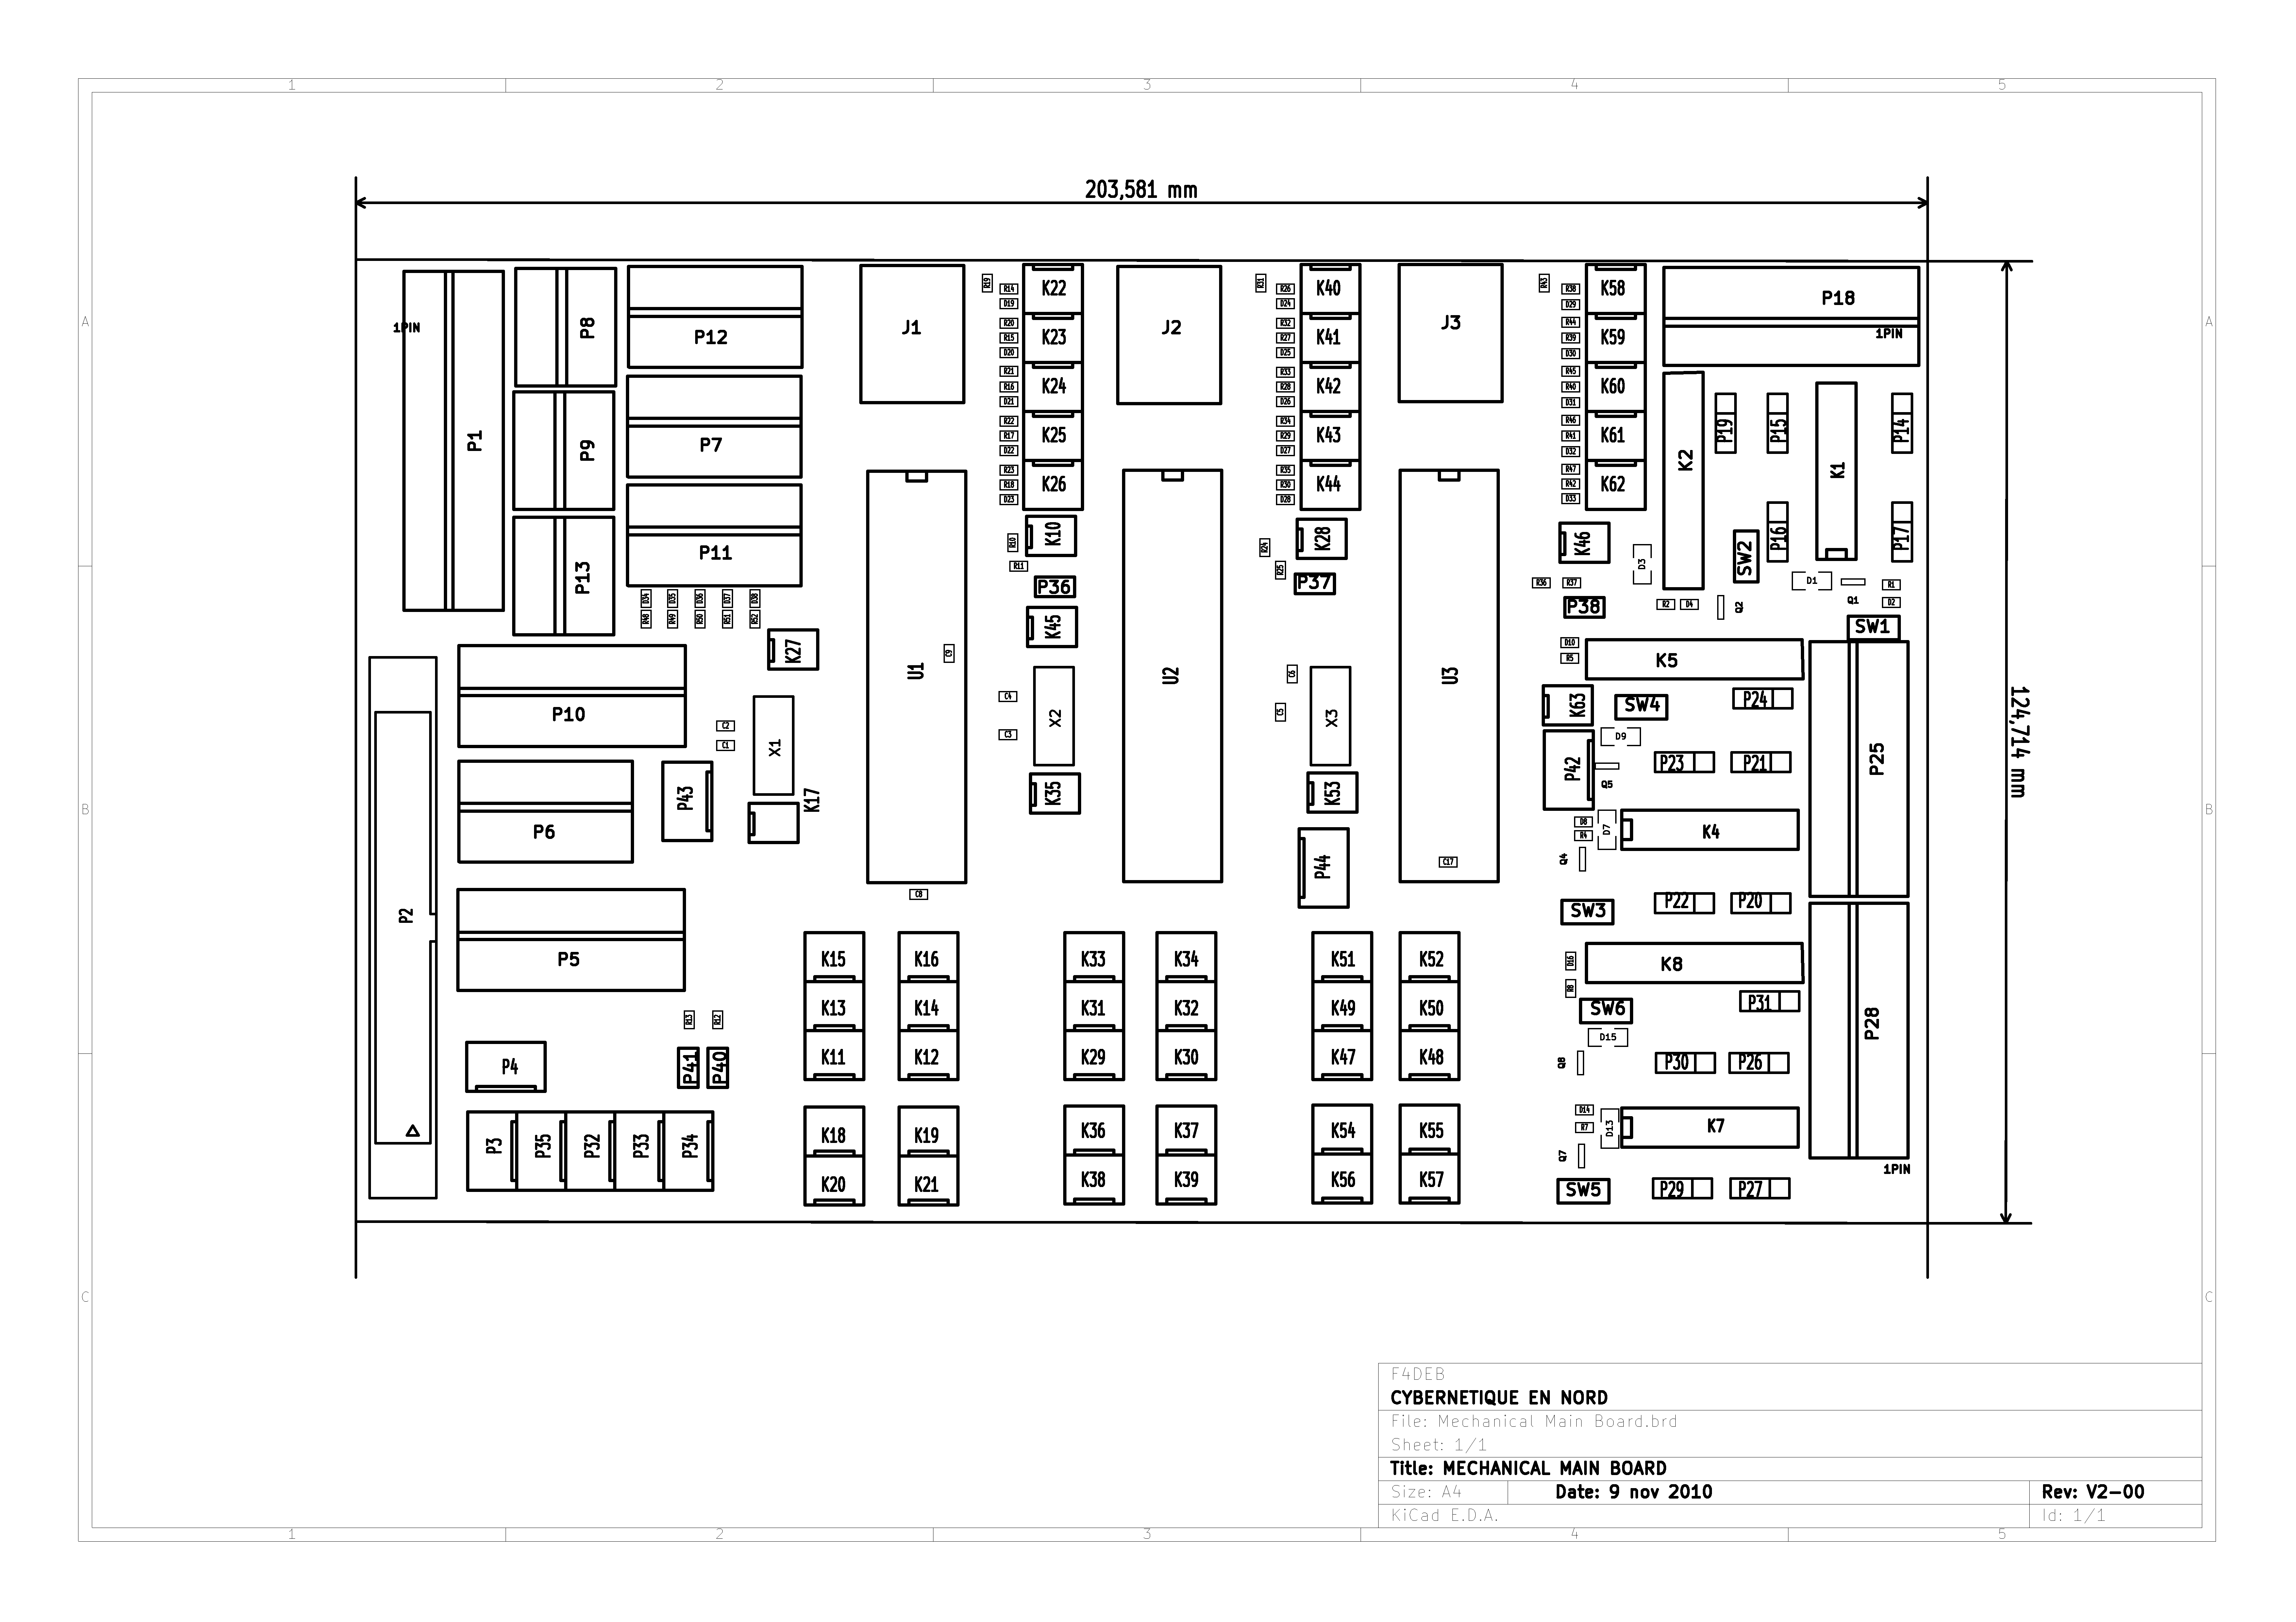
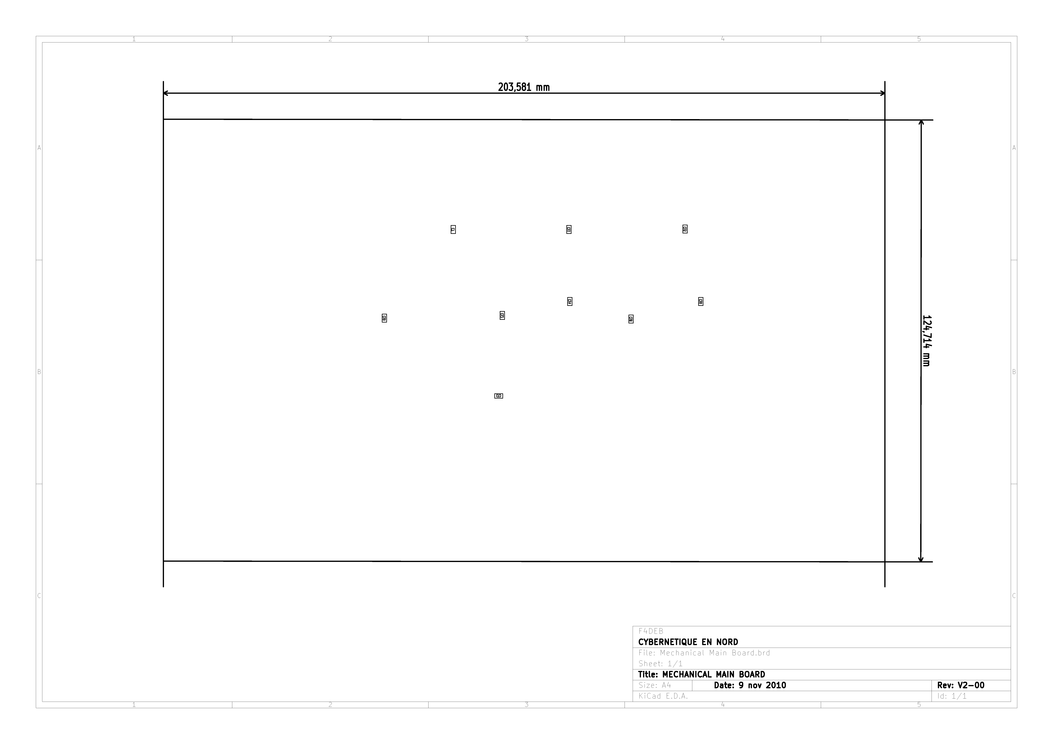

Liste des commandes, nomenclature

REPERE TOPO | VALEUR | REFERENCE
C1 | 22p | SM0603
C2 | 22p | SM0603
C3 | 22p | SM0603
C4 | 22p | SM0603
C5 | 22p | SM0603
C6 | 22p | SM0603
C7 | 100n | SM0603
C8 | 100n | SM0603
C9 | 100n | SM0603
C10 | 100n | SM0603
C11 | 100n | SM0603
C12 | 100n | SM0603
C13 | 100n | SM0603
C14 | 100n | SM0603
C15 | 100n | SM0603
C16 | 100n | SM0603
C17 | 100n | SM0603
C18 | 100n | SM0603
D1 | DIODE | SM1206
D2 | LED | SM0603
D3 | DIODE | SM1206
D4 | LED | SM0603
D7 | DIODE | SM1206
D8 | LED | SM0603
D9 | DIODE | SM1206
D10 | LED | SM0603
D13 | DIODE | SM1206
D14 | LED | SM0603
D15 | DIODE | SM1206
D16 | LED | SM0603
D19 | LED | SM0603
D20 | LED | SM0603
D21 | LED | SM0603
D22 | LED | SM0603
D23 | LED | SM0603
D24 | LED | SM0603
D25 | LED | SM0603
D26 | LED | SM0603
D27 | LED | SM0603
D28 | LED | SM0603
REPERE TOPO | VALEUR | REFERENCE
D29 | LED | SM0603
D30 | LED | SM0603
D31 | LED | SM0603
D32 | LED | SM0603
D33 | LED | SM0603
D34 | LED | SM0603
D35 | LED | SM0603
D36 | LED | SM0603
D37 | LED | SM0603
D38 | LED | SM0603
J1 | RJ12 | RJ12_CMS
J2 | RJ12 | RJ12_CMS
J3 | RJ12 | RJ12_CMS
K1 | RELAY_A_2RT | RELAY_2RT
K2 | RELAY_1RT_FINDER | RELAY_1RT_FINDER
K4 | RELAY_A_2RT | RELAY_2RT
K5 | RELAY_1RT_FINDER | RELAY_1RT_FINDER
K7 | RELAY_A_2RT | RELAY_2RT
K8 | RELAY_1RT_FINDER | RELAY_1RT_FINDER
K10 | CONN_2 | KK-2Male Vertical
K11 | CONN_3 | KK-3Male Vertical
K12 | CONN_3 | KK-3Male Vertical
K13 | CONN_3 | KK-3Male Vertical
K14 | CONN_3 | KK-3Male Vertical
K15 | CONN_3 | KK-3Male Vertical
K16 | CONN_3 | KK-3Male Vertical
K17 | CONN_2 | KK-2Male Vertical
K18 | CONN_3 | KK-3Male Vertical
K19 | CONN_3 | KK-3Male Vertical
K20 | CONN_3 | KK-3Male Vertical
K21 | CONN_3 | KK-3Male Vertical
K22 | CONN_3 | KK-3Male Vertical
K23 | CONN_3 | KK-3Male Vertical
K24 | CONN_3 | KK-3Male Vertical
K25 | CONN_3 | KK-3Male Vertical
K26 | CONN_3 | KK-3Male Vertical
K27 | CONN_2 | KK-2Male Vertical
K28 | CONN_2 | KK-2Male Vertical
K29 | CONN_3 | KK-3Male Vertical
K30 | CONN_3 | KK-3Male Vertical
K31 | CONN_3 | KK-3Male Vertical
K32 | CONN_3 | KK-3Male Vertical
REPERE TOPO | VALEUR | REFERENCE
K33 | CONN_3 | KK-3Male Vertical
K34 | CONN_3 | KK-3Male Vertical
K35 | CONN_2 | KK-2Male Vertical
K36 | CONN_3 | KK-3Male Vertical
K37 | CONN_3 | KK-3Male Vertical
K38 | CONN_3 | KK-3Male Vertical
K39 | CONN_3 | KK-3Male Vertical
K40 | CONN_3 | KK-3Male Vertical
K41 | CONN_3 | KK-3Male Vertical
K42 | CONN_3 | KK-3Male Vertical
K43 | CONN_3 | KK-3Male Vertical
K44 | CONN_3 | KK-3Male Vertical
K45 | CONN_2 | KK-2Male Vertical
K46 | CONN_2 | KK-2Male Vertical
K47 | CONN_3 | KK-3Male Vertical
K48 | CONN_3 | KK-3Male Vertical
K49 | CONN_3 | KK-3Male Vertical
K50 | CONN_3 | KK-3Male Vertical
K51 | CONN_3 | KK-3Male Vertical
K52 | CONN_3 | KK-3Male Vertical
K53 | CONN_2 | KK-2Male Vertical
K54 | CONN_3 | KK-3Male Vertical
K55 | CONN_3 | KK-3Male Vertical
K56 | CONN_3 | KK-3Male Vertical
K57 | CONN_3 | KK-3Male Vertical
K58 | CONN_3 | KK-3Male Vertical
K59 | CONN_3 | KK-3Male Vertical
K60 | CONN_3 | KK-3Male Vertical
K61 | CONN_3 | KK-3Male Vertical
K62 | CONN_3 | KK-3Male Vertical
K63 | CONN_2 | KK-2Male Vertical
P1 | CONN_12 | WEIDMULLER12
P2 | HE10-40 | HE10_40
P3 | CONN_4 | KK-4Male Vertical
P4 | CONN_4 | KK-4Male Vertical
P5 | CONN_8 | WEIDMULLER-8
P6 | CONN_6 | WEIDMULLER-6
P7 | CONN_6 | WEIDMULLER-6
P8 | CONN_4 | WEIDMULLER-4
P9 | CONN_4 | WEIDMULLER-4
P10 | CONN_8 | WEIDMULLER-8
P11 | CONN_6 | WEIDMULLER-6
P12 | CONN_6 | WEIDMULLER-6
REPERE TOPO | VALEUR | REFERENCE
P13 | CONN_4 | WEIDMULLER-4
P14 | CAVALIER2 | SIL-3
P15 | CAVALIER2 | SIL-3
P16 | CAVALIER2 | SIL-3
P17 | CAVALIER2 | SIL-3
P18 | CONN_9 | WEIDMULLER9
P19 | CAVALIER2 | SIL-3
P20 | CAVALIER2 | SIL-3
P21 | CAVALIER2 | SIL-3
P22 | CAVALIER2 | SIL-3
P23 | CAVALIER2 | SIL-3
P24 | CAVALIER2 | SIL-3
P25 | CONN_9 | WEIDMULLER9
P26 | CAVALIER2 | SIL-3
P27 | CAVALIER2 | SIL-3
P28 | CONN_9 | WEIDMULLER9
P29 | CAVALIER2 | SIL-3
P30 | CAVALIER2 | SIL-3
P31 | CAVALIER2 | SIL-3
P32 | CONN_4 | KK-4Male Vertical
P33 | CONN_4 | KK-4Male Vertical
P34 | CONN_4 | KK-4Male Vertical
P35 | CONN_4 | KK-4Male Vertical
P36 | CAVALIER | CAVALIER
P37 | CAVALIER | CAVALIER
P38 | CAVALIER | CAVALIER
P40 | CAVALIER | CAVALIER
P41 | CAVALIER | CAVALIER
P42 | CONN_4 | KK-4Male Vertical
P43 | CONN_4 | KK-4Male Vertical
P44 | CONN_4 | KK-4Male Vertical
Q1 | BSS123 | SOT23EBC
Q2 | BSS123 | SOT23EBC
Q4 | BSS123 | SOT23EBC
Q5 | BSS123 | SOT23EBC
Q7 | BSS123 | SOT23EBC
Q8 | BSS123 | SOT23EBC
R1 | 820 | SM0603
R2 | 820 | SM0603
R4 | 820 | SM0603
R5 | 820 | SM0603
R7 | 820 | SM0603
R8 | 820 | SM0603
REPERE TOPO | VALEUR | REFERENCE
R10 | 10k | SM0603
R11 | 15 | SM0603
R12 |  | SM0603
R13 |  | SM0603
R14 | 470 | SM0603
R15 | 470 | SM0603
R16 | 470 | SM0603
R17 | 470 | SM0603
R18 | 470 | SM0603
R19 | 470 | SM0603
R20 | 470 | SM0603
R21 | 470 | SM0603
R22 | 470 | SM0603
R23 | 470 | SM0603
R24 | 10k | SM0603
R25 | 15 | SM0603
R26 | 470 | SM0603
R27 | 470 | SM0603
R28 | 470 | SM0603
R29 | 470 | SM0603
R30 | 470 | SM0603
R31 | 470 | SM0603
R32 | 470 | SM0603
R33 | 470 | SM0603
R34 | 470 | SM0603
R35 | 470 | SM0603
R36 | 10k | SM0603
R37 | 15 | SM0603
R38 | 470 | SM0603
R39 | 470 | SM0603
R40 | 470 | SM0603
R41 | 470 | SM0603
R42 | 470 | SM0603
R43 | 470 | SM0603
R44 | 470 | SM0603
R45 | 470 | SM0603
R46 | 470 | SM0603
R47 | 470 | SM0603
R48 | 1k | SM0603
R49 | 820 | SM0603
R50 | 680 | SM0603
R51 | 330 | SM0603
REPERE TOPO | VALEUR | REFERENCE
R52 | 220 | SM0603
SW1 | SW_PUSH_SMALL | SW2
SW2 | SW_PUSH_SMALL | SW2
SW3 | SW_PUSH_SMALL | SW2
SW4 | SW_PUSH_SMALL | SW2
SW5 | SW_PUSH_SMALL | SW2
SW6 | SW_PUSH_SMALL | SW2
U1 | DSPIC30F4013 | DIP40__600_ELL
U2 | DSPIC30F4013 | DIP40__600_ELL
U3 | DSPIC30F4013 | DIP40__600_ELL
X1 | CRYSTAL1 | QTZ2
X2 | CRYSTAL1 | QTZ2
X3 | CRYSTAL1 | QTZ2

Validation de la carte

Change Logs :

V 2-00 : Version de Base

V2-10
  - Regrouper les alimentations et les 2 moteurs sur un seul connecteur
  - Broche 20 HE10-40 NON UTILISABLE (détrompeur). A déplacer sur la broche 32
  - Rajouter 2 colonettes au centre de la carte
  - Ajouter sérigraphie broche 1 connecteur 40 broches

Photos

